Ideation Phase
Empathize & Discover

Date | 02/10/2026
Team ID | SWTID-2026-3118
Project Name | IMPORT DATA USING TRANSFORM MAPS (SPREADSHEET)
Maximum Marks | 4 Marks

Empathy Map Canvas:
An empathy map is a simple, easy-to-digest visual that captures knowledge about a user’s behaviours and attitudes.

It is a useful tool to helps teams better understand their users.
Creating an effective solution requires understanding the true problem and the person who is experiencing it. The exercise of creating the map helps participants consider things from the user’s perspective along with his or her goals and challenges.
Example:
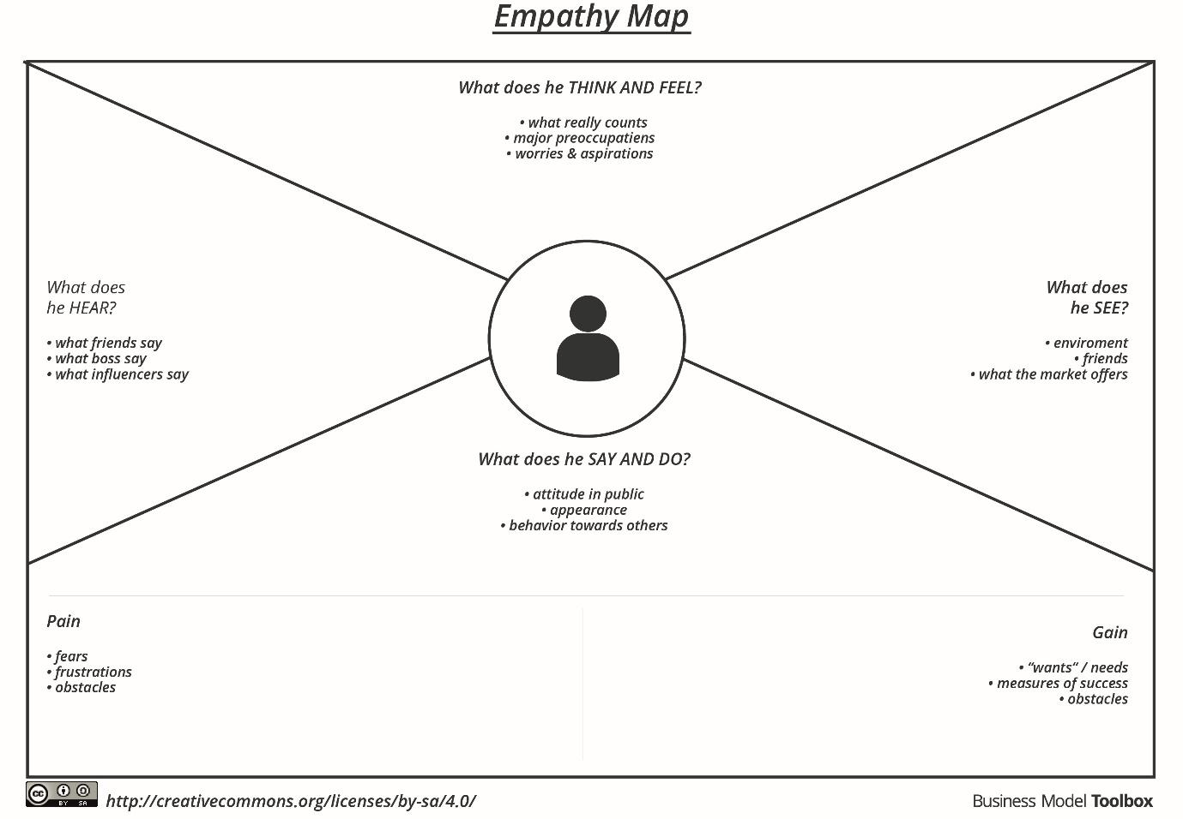

Reference: https://www.mural.co/templates/empathy-map-canvas

Example: Food Ordering & Delivery Application
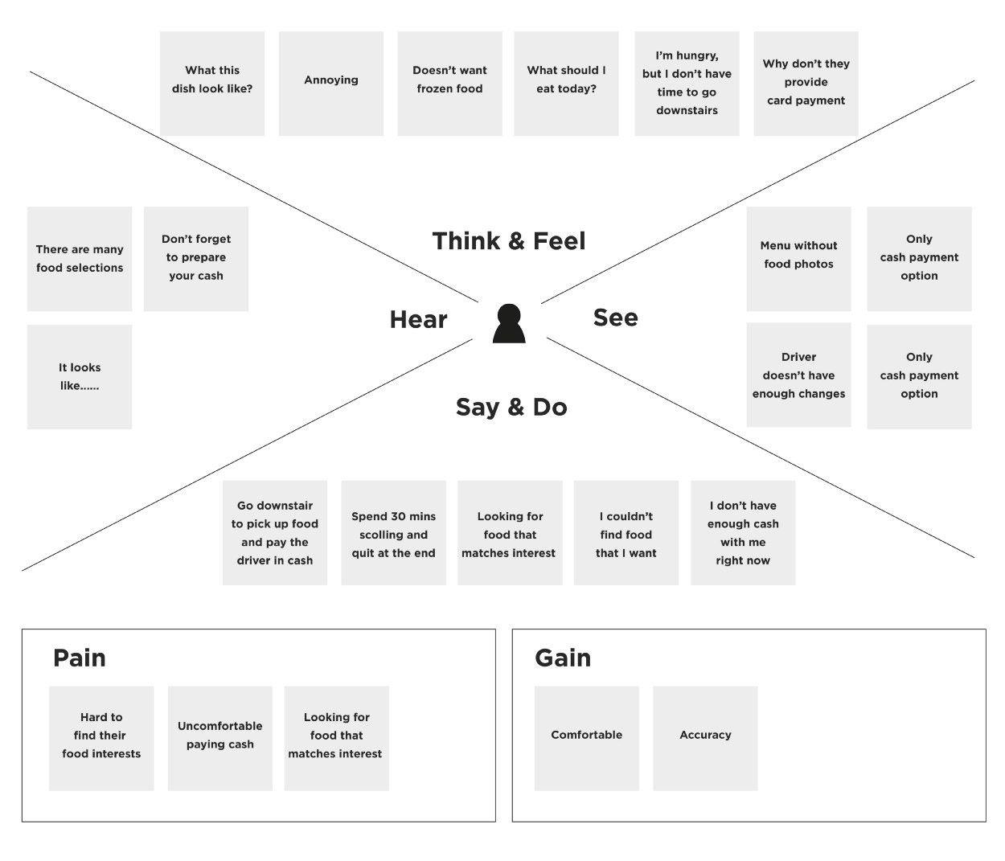

Employee Import Empathy Map
Working persona: HR operations data coordinator who prepares employee spreadsheets and works with a ServiceNow administrator.
THINK AND FEEL  Needs accurate employee records and a dependable import process.  Worries that duplicates or incorrect updates may go unnoticed.  Values a clear confirmation that each import succeeded. | SEE  Employee spreadsheets with IDs, names, emails, departments, and locations.  ServiceNow import and transform statuses.  Employee records and Department or Location reports.
HEAR  Requests to add new employees and update existing details.  Questions about missing or outdated employee records.  Reminders to keep employee data accurate. | SAY AND DO  Prepare and check the spreadsheet headers and rows.  Load the file into the Employee Import staging table.  Map fields, run the transform, and review history and target records.
PAINS  Manual entry takes time.  Mismatched fields or incomplete rows can cause errors.  Repeated imports can create duplicates.  Unclear results make it harder to confirm changes. | GAINS  Employee ID coalesce updates matching records and avoids duplicates.  New IDs create new employee records.  Transform History shows inserted, updated, and ignored rows.  Reports and a dashboard make employee data easier to review.
Project outcome: A repeatable spreadsheet import that inserts new employees, updates matching Employee IDs, and makes results visible for review.

